**Exercise - Run load tests in Azure Pipelines**

In this section, you run the test plan that Mara and Tim created in the release pipeline. The test plan uses Apache JMeter to run load tests.

Here's how you run the tests:

* Fetch and check out a Git branch that implements the tests.
* Modify your pipeline to install JMeter, run the test plan, transform the results to JUnit, and publish the results to Azure Pipelines.
* Push your branch to GitHub, watch the tests run in Azure Pipelines, and then examine the results.

**Fetch the branch from GitHub**

In this section, you fetch the jmeter branch from GitHub and check out, or switch to, that branch.

This branch contains the *Space Game* project that you worked with in previous modules. It also contains an Azure Pipelines configuration to start with.

1. In Visual Studio Code, open the integrated terminal.
2. To download a branch named jmeter from the Microsoft repository and switch to that branch, run the following git fetch and git checkout commands:

**Bash**

**git fetch upstream jmeter**

**git checkout -b jmeter upstream/jmeter**

Recall that *upstream* refers to the Microsoft GitHub repository. Your project's Git configuration understands the upstream remote because you set up that relationship when you forked the project from the Microsoft repository and cloned it locally.

Shortly, you'll push this branch up to your GitHub repository, known as origin.

1. Optionally, in Visual Studio Code, open the *azure-pipelines.yml* file. Review the initial configuration.

The configuration resembles the ones that you created in previous modules in this learning path. It builds only the application's **Release** configuration. For brevity, it omits the triggers, manual approvals, and tests that you set up in previous modules.

**Note**

A more robust configuration might specify the branches that participate in the build process. For example, to help verify code quality, you might run unit tests each time you push up a change on any branch. You might also deploy the application to an environment that performs more exhaustive testing. But you do this deployment only when you have a pull request, when you have a release candidate, or when you merge code to *master*.

For more information, see [**Implement a code workflow in your build pipeline by using Git and GitHub**](https://docs.microsoft.com/en-us/learn/modules/implement-code-workflow) and [**Build pipeline triggers**](https://docs.microsoft.com/en-us/azure/devops/pipelines/build/triggers?view=azure-devops&tabs=yaml).

1. Optionally, in Visual Studio Code, you can check out the JMeter test plan file, *LoadTest.jmx*, and the XLST transform, *JMeter2JUnit.xsl*. The XLST file transforms the JMeter output to JUnit so that Azure Pipelines can visualize the results.

**Add variables to Azure Pipelines**

Tim's original test plan provides a hard-coded value for the host name of the *Space Game* website that runs in the **staging** environment.

To make the test plan more flexible, your version uses a JMeter property. Think of a property as a variable that you can set from the command line.

Here's how the hostname variable is defined in JMeter:

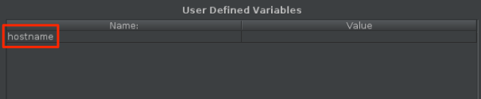

Here's how the hostname variable uses the [__P](https://jmeter.apache.org/usermanual/functions.html#__P) function to read the hostname variable.

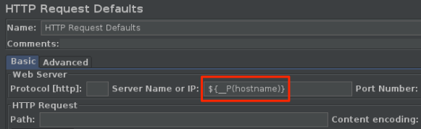

The corresponding test plan file, *LoadTest.jmx*, specifies this variable and uses it to set the host name.

When you run JMeter from the command line, you use the -J argument to set the hostname property. Here's an example:

**Bash**

**apache-jmeter-5.3/bin/./jmeter -n -t LoadTest.jmx -o Results.xml -Jhostname=tailspin-space-game-web-staging-1234.azurewebsites.net**

Here you set the STAGING_HOSTNAME variable in Azure Pipelines. This variable points to your site's host name that runs on App Service in your **staging** environment. You also set the jmeterVersion to specify the version of JMeter to install.

When the agent runs, these variables are automatically exported to the agent as environment variables. So your pipeline configuration can run JMeter this way:

**Bash**

**apache-jmeter-5.3/bin/./jmeter -n -t LoadTest.jmx -o Results.xml -Jhostname=$(STAGING_HOSTNAME)**

Let's add the pipeline variables now, before you update your pipeline configuration. To do so:

1. In Azure DevOps, go to your **Space Game - web - Nonfunctional tests** project.
2. Under **Pipelines**, select **Library**.
3. Select the **Release** variable group.
4. Under **Variables**, select **+ Add**.
5. For the name of your variable, enter *STAGING_HOSTNAME*. For its value, enter the URL of the App Service instance that corresponds to your **staging** environment, such as *tailspin-space-game-web-staging-1234.azurewebsites.net*.

**Important**

Don't include the http:// or https:// protocol prefix in your value. JMeter provides the protocol when the tests run.

1. Add a second variable named *jmeterVersion*. For its value, specify *5.3*.

**Note**

This is the version of JMeter that we last used to test this module. To get the latest version, see [**Download Apache JMeter**](https://jmeter.apache.org/download_jmeter.cgi).

1. To save your variable to the pipeline, near the top of the page, select **Save**.

Your variable group resembles this one:

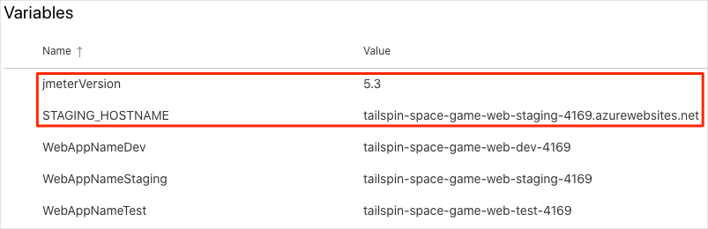

**Modify the pipeline configuration**

In this section, you modify the pipeline to run your load tests during the *Staging* stage.

1. In Visual Studio Code, open the *azure-pipelines.yml* file. Then modify the file:

**Tip**

You can replace the entire file or just update the part that's highlighted.

**Yml**

trigger:

- '*'

variables:

buildConfiguration: 'Release'

stages:

- stage: 'Build'

displayName: 'Build the web application'

jobs:

- job: 'Build'

displayName: 'Build job'

pool:

vmImage: 'ubuntu-18.04'

demands:

- npm

variables:

wwwrootDir: 'Tailspin.SpaceGame.Web/wwwroot'

dotnetSdkVersion: '3.1.300'

steps:

- task: UseDotNet@2

displayName: 'Use .NET Core SDK $(dotnetSdkVersion)'

inputs:

version: '$(dotnetSdkVersion)'

- task: Npm@1

displayName: 'Run npm install'

inputs:

verbose: false

- script: './node_modules/.bin/node-sass $(wwwrootDir) --output $(wwwrootDir)'

displayName: 'Compile Sass assets'

- task: gulp@1

displayName: 'Run gulp tasks'

- script: 'echo "$(Build.DefinitionName), $(Build.BuildId), $(Build.BuildNumber)" > buildinfo.txt'

displayName: 'Write build info'

workingDirectory: $(wwwrootDir)

- task: DotNetCoreCLI@2

displayName: 'Restore project dependencies'

inputs:

command: 'restore'

projects: '**/*.csproj'

- task: DotNetCoreCLI@2

displayName: 'Build the project - $(buildConfiguration)'

inputs:

command: 'build'

arguments: '--no-restore --configuration $(buildConfiguration)'

projects: '**/*.csproj'

- task: DotNetCoreCLI@2

displayName: 'Publish the project - $(buildConfiguration)'

inputs:

command: 'publish'

projects: '**/*.csproj'

publishWebProjects: false

arguments: '--no-build --configuration $(buildConfiguration) --output $(Build.ArtifactStagingDirectory)/$(buildConfiguration)'

zipAfterPublish: true

- publish: '$(Build.ArtifactStagingDirectory)'

artifact: drop

- stage: 'Dev'

displayName: 'Deploy to the dev environment'

dependsOn: Build

jobs:

- deployment: Deploy

pool:

vmImage: 'ubuntu-18.04'

environment: dev

variables:

- group: Release

strategy:

runOnce:

deploy:

steps:

- download: current

artifact: drop

- task: AzureWebApp@1

displayName: 'Azure App Service Deploy: website'

inputs:

azureSubscription: 'Resource Manager - Tailspin - Space Game'

appName: '$(WebAppNameDev)'

package: '$(Pipeline.Workspace)/drop/$(buildConfiguration)/*.zip'

- stage: 'Test'

displayName: 'Deploy to the test environment'

dependsOn: Dev

jobs:

- deployment: Deploy

pool:

vmImage: 'ubuntu-18.04'

environment: test

variables:

- group: 'Release'

strategy:

runOnce:

deploy:

steps:

- download: current

artifact: drop

- task: AzureWebApp@1

displayName: 'Azure App Service Deploy: website'

inputs:

azureSubscription: 'Resource Manager - Tailspin - Space Game'

appName: '$(WebAppNameTest)'

package: '$(Pipeline.Workspace)/drop/$(buildConfiguration)/*.zip'

- stage: 'Staging'

displayName: 'Deploy to the staging environment'

dependsOn: Test

jobs:

- deployment: Deploy

pool:

vmImage: 'ubuntu-18.04'

environment: staging

variables:

- group: 'Release'

strategy:

runOnce:

deploy:

steps:

- download: current

artifact: drop

- task: AzureWebApp@1

displayName: 'Azure App Service Deploy: website'

inputs:

azureSubscription: 'Resource Manager - Tailspin - Space Game'

appName: '$(WebAppNameStaging)'

package: '$(Pipeline.Workspace)/drop/$(buildConfiguration)/*.zip'

- job: RunLoadTests

dependsOn: Deploy

displayName: 'Run load tests'

pool:

vmImage: 'ubuntu-18.04'

variables:

- group: Release

steps:

- script: |

wget -c ftp.ps.pl/pub/apache/jmeter/binaries/apache-jmeter-$(jmeterVersion).tgz

tar -xf apache-jmeter-$(jmeterVersion).tgz

displayName: 'Install Apache JMeter'

- script: apache-jmeter-$(jmeterVersion)/bin/./jmeter -n -t LoadTest.jmx -o Results.xml -Jhostname=$(STAGING_HOSTNAME)

displayName: 'Run Load tests'

- script: |

sudo apt-get update

sudo apt-get install xsltproc

xsltproc JMeter2JUnit.xsl Results.xml > JUnit.xml

displayName: 'Transform JMeter output to JUnit'

- task: PublishTestResults@2

inputs:

testResultsFormat: JUnit

testResultsFiles: JUnit.xml

Here's a summary of the changes:

* + The RunLoadTests job does load testing from a Linux agent.
  + The RunLoadTests job depends on the Deploy job to ensure that the jobs are run in the correct order. You need to deploy the website to App Service before you can run the load tests. If you don't specify this dependency, jobs within the stage can run in any order or run in parallel.
  + The first script task downloads and installs JMeter. The jmeterVersion pipeline variable specifies the version of JMeter to install.
  + The second script task runs JMeter. The -J argument sets the hostname property in JMeter by reading the STAGING_HOSTNAME variable from the pipeline.
  + The third script task installs **xsltproc**, an XSLT processor, and transforms the JMeter output to JUnit.
  + The PublishTestResults@2 task publishes the resulting JUnit report, *JUnit.xml*, to the pipeline. Azure Pipelines can help you visualize the test results.

1. In the integrated terminal, add *azure-pipelines.yml* to the index, commit the changes, and push the branch up to GitHub.

**Bash**

**git add azure-pipelines.yml**

**git commit -m "Run load tests with Apache JMeter"**

**git push origin jmeter**

**Watch Azure Pipelines run the tests**

Here you watch the pipeline run. You see the load tests run during *Staging*.

1. In Azure Pipelines, go to the build and trace it as it runs.

During *Staging*, you see the load tests run after the website is deployed.

1. After the build finishes, go to the summary page.

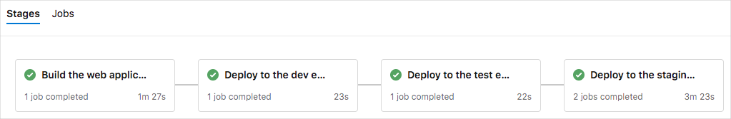

You see that the deployment and the load tests finished successfully.

1. Near the top of the page, note the summary.

You see that the build artifact for the *Space Game* website is published just like always. Also note the **Tests and coverage** section, which shows that the load tests have passed.



1. Select the test summary to see the full report.

The report shows that both tests have passed.

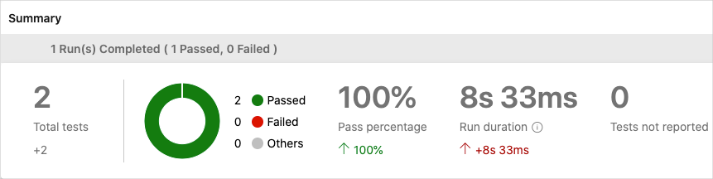

If any test were to fail, you would see detailed results of the failure. From those results, you could investigate the source of the failure.

Recall that the XSLT file produces a JUnit file, *JUnit.xml*. The JUnit file answers these two questions:

* + Is the average request time less than one second?
  + Do fewer than 10 percent of requests take more than one second to complete?

The report proves that these requirements are met. To see more details, select the **Outcome** arrow in the report. Then make sure that only **Passed** is selected.

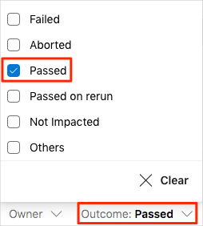

You see that the **Average Response Time** and **Max Response Time** test cases both succeeded.

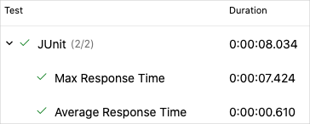

**Note**

You're using the **B1** App Service plan, which runs on the **Basic** tier. This plan is intended for apps that have low traffic requirements, such as apps in a test environment. Because of this plan, the performance of your website might be less than you expect. In practice, you would choose a plan for the **staging** environment that more closely matches your production environment. For example, the **Standard** and **Premium** plans are for production workloads. These run on dedicated virtual machine instances.

**Tim:** Mara, I don't need to tell you this, but at first I resisted the changes you proposed. I feared losing control over my production environment. But even with all these changes, I still have control. Plus, we now do load testing earlier in the process. In the past, I waited until just before we released because the process was time-consuming. Now we can continuously monitor how our websites perform. If performance drops, we know which change caused the decline.

**Mara:** Early testing also gives us enough time to fix the problem, rather than scrambling at the last minute. I love your attitude, Tim. Thanks for sticking with it!